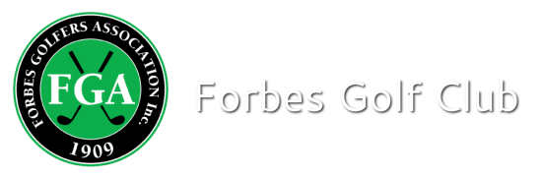

Competition Result

Event: 18-Hole Individual Stableford Medley
Sponsor: Fathers Day
Date: 6-9-2020 Num of Players: 14

Winner Ethel Coombs (22) 40 points c/b
Runner Up Shirley Redfern (41) 40 points

Ball run down to: 34 pts
Adam Demidjuk
Barbara Drabsch

NTP- 9th: C O’Shea
18th: A Demidjuk

