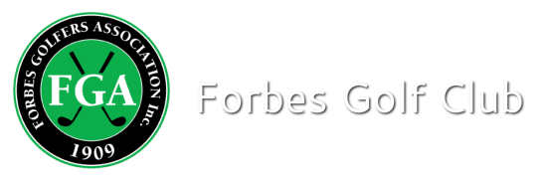

Competition Result

Event: Monthly Medal - Stroke
Sponsor: Mc Feeters Motor Museum
Date: 5-09-2020 Num of Players: 103

A-Grade Winner: Michael Wood (8) 67 nett
A-Grade R-Up: Warwick Jennings (12) 68 nett
Nowra

B-Grade Winner: Doug Churchill (15) 64 nett
B-Grade R-Up: Barry Parker (18) 67 nett

C-Grade Winner: Liam Whitfield (26) 62 nett
C-Grade R-Up: Ben Coles (22) 63 nett

Ball run down: 71 nett c/b
NTP
Proshop Super Pin John Boyle 125cms
9th Jack Dobell
18th Steve Betland

