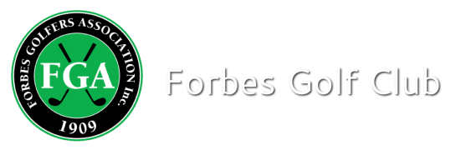

Competition Result

Event: Individual Stableford (ONE DIVISION)
Sponsor: A KINGSTON
Date: 19-8-20 Num of Players: 21

Winner: Kate Steele-Park (37) 33 Points
Runner-Up: Janet Smith (20) 31 Points C/B

BALL WINNERS
NAME: Evelyn Uphill 31 points
NAME: Linda Cowhan 30 points
NAME: Robin Lyell 29 points c/b

NTP 9TH: HEATHER DAVIDSON (1 ball)
NTP 18TH : LINDA POLLOCK (1 ball)

