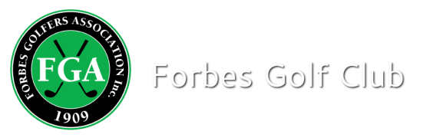
Competition Result

Event: KENO 2 Ball Ambrose
Sponsor: Marg & Ron Hurst and Shirley Redfern
Date: 29.08.20 Number of Players: 48 pairs
Men
Winners Nett: Shane Sallaway & Doug Churchill Nett 58.5
Mixed
Winners Nett: Fleur Von Mengerson- Wells & Phil Wells Nett 59.8
Ladies
Winners Nett: Brianna & Carolyn Duncan Nett 64.8
Ball Sweep: 67 nett c/b

PROSHOP SUPER PIN 3RD HOLE
Winner: Mark Hawker Pro Shop Voucher (89 cms)

NTP: Men 9th P. Cowhan
18th P Cowhan
Ladies 9th B. Duncan
18th B Duncan

